FJORD HORSES FOR SALE OR LEASE
1 January 2020
This is a summarised list of Fjords known by the Fjord Promotional Group to be for sale as at 01/01/2020. Please contact the relevant owner for more details. Information about Australian studs and breeders can be found at www.fjordhorse.org.au

VICTORIA
BLACKWOOD RIDGE PERIDOT (see photograph on next page)
15/10/2019 Brown dun filly, out of Seaview Park Hilde by Camel Hills White Knight (imp). Expected to mature approx 14hh. Available after weaning. Peri is super friendly and well handled. Will be registered with the APSB, fully vaccinated for tetanus and strangles and be kept up to date with worming.
Contact Sharon Smith on 0423350015 or smiths.saddlery@bigpond.com

BLACKWOOD RIDGE P (still to be named)
19/11/2019 Brown dun colt, out of Seaview Park Jinx by Camel Hills White Knight (imp). Expected to mature approx14.1/14.2hh. Available after weaning. He is a tall foal with beautiful movement. He is super friendly and well handled. Will be registered with the APSB, fully vaccinated for tetanus and strangles and be kept up to date with worming.
Contact Sharon Smith on 0423350015 or smiths.saddlery@bigpond.com

HARKAWAY LODGE PADDINGTON
04/10/19 Brown dun (to be confirmed) colt foal. Out of Blackwood Ridge Fjola by Tambo River Yahzuo (frozen semen USA). Mature approx. 14hh, very friendly and people orientated. Available at weaning age.
Contact Julia Grave on 0408 361 668 or email fjordsandhighlands@bigpond.com
TASMANIA
PALANA ORLANDO (APSB 79443)
Brown dun gelding, tall and sensitive with lovely movement, born 28/10/18. Sire: Palana Tyson Dam: Seaview Park Bodil. Expect to mature 14 hands.
Contact Kerrie Prescott at Palana Stud on 0408 088 495 or kerrieprescott@bigpond.com
FUTURE FOALS

PALANA STUD (TASMANIA)

Expecting a foal out of Rachem Kerrie’s Karisma by Palana Tyson.

Contact Kerrie Prescott on 0408 088 495 or kerrieprescott@bigpond.com

HARKAWAY LODGE STUD (UPPER BEACONSFIELD, VICTORIA)

Expecting a foal out of Seaview Park Astrio by Tambo River Yahzuo (Pandora X MVF Erlend (USA)).

Contact Julia Grave on 0408 361 668 or fjordsandhighlands@bigpond.com

TAMBO RIVER STUD (VICTORIA)

Expecting several foals in the 2019-20 season by grey stallion Seaview Park Xanthus.

Contact Heidi Murphy at tamboriverfjords@gmail.com

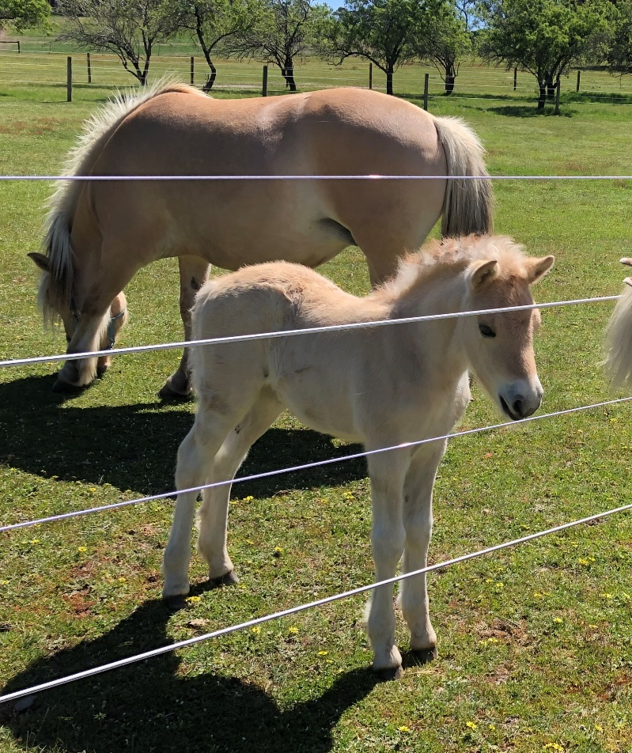
ABOVE: Blackwood Ridge Peridot

