FJORD HORSES FOR SALE OR LEASE
1 February 2020
This is a summarised list of Fjords known by the Fjord Promotional Group to be for sale as at 01/02/2020. Please contact the relevant owner for more details. Information about Australian studs and breeders can be found at www.fjordhorse.org.au

FJORDS AVAILABLE IN VICTORIA
BLACKWOOD RIDGE PERIDOT  15/10/2019 brown dun filly, out of Seaview Park Hilde by Camel Hills White Knight (imp).  Expected to mature approx 14hh.  Available after weaning.  Peri is super friendly and well handled.  Will be registered with the APSB, fully vaccinated for tetanus and strangles and kept up to date with worming.  Contact Sharon Smith on 0423350015 or smiths.saddlery@bigpond.com | 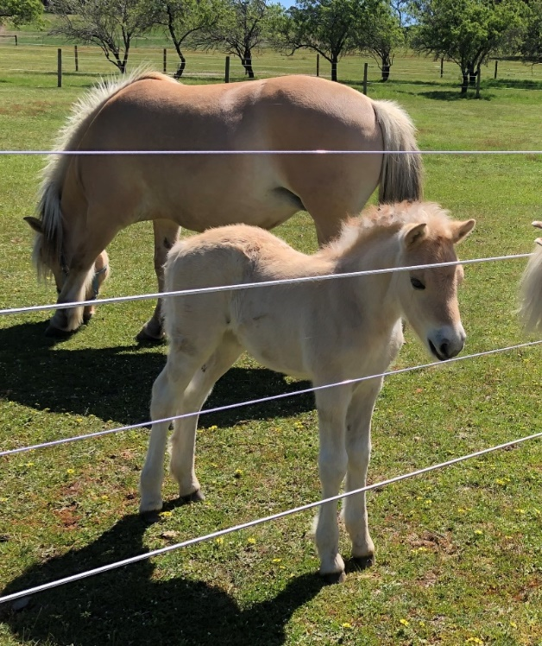
BLACKWOOD RIDGE PETRONAS  19/11/2019 brown dun colt, out of Seaview Park Jinx by Camel Hills White Knight (imp).  Expected to mature approx14.1/14.2hh.  Available after weaning. He is a tall foal with beautiful movement.  He is super friendly and well handled.  Will be registered with the APSB, fully vaccinated for tetanus and strangles and be kept up to date with worming.  Contact Sharon Smith on 0423350015 or smiths.saddlery@bigpond.com | 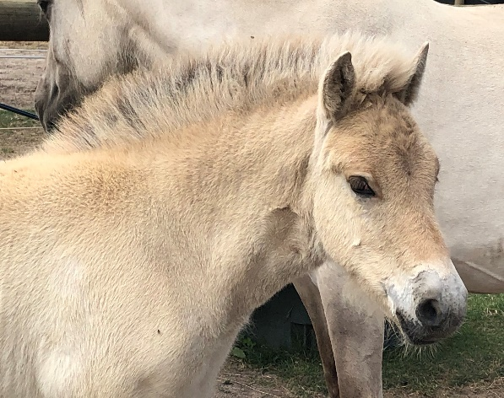
CHURCH HILL PARK PERSEUS  09/12/2019 brown dun colt (to be gelded), out of Harkaway Lodge Genna by Palana Ignatious.  Expected to mature 13.2/13.3hh.  Available upon weaning.  Percy is an extremely friendly little man, very brave and inquisitive also.  Well handled from birth.  Will be taught all the basics. Will be registered with the APSB, kept up to date with worming and fully vaccinated for tetanus and strangles.  Contact Leigh Church on 0413 019 993 or email leighc284@gmail.com | 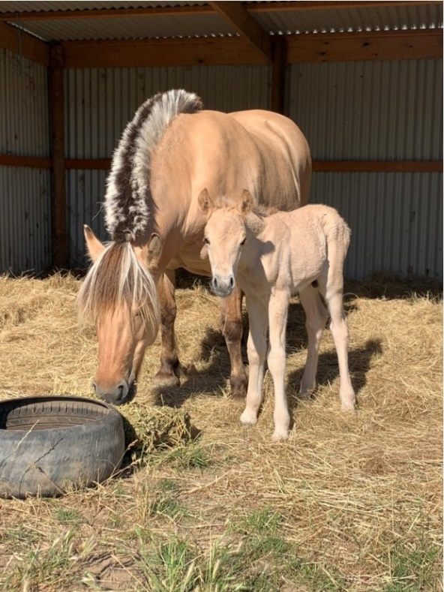

FJORDS AVAILABLE IN TASMANIA
PALANA ORLANDO  (APSB 79443)  28/10/18 brown dun gelding with dark golden colouring, out of Seaview Park Bodil by Palana Tyson.  Expected to mature 14hh.  Orlando is tall and sensitive with lovely movement.  Contact Kerrie Prescott at Palana Stud on 0408 088 495 or kerrieprescott@bigpond.com | 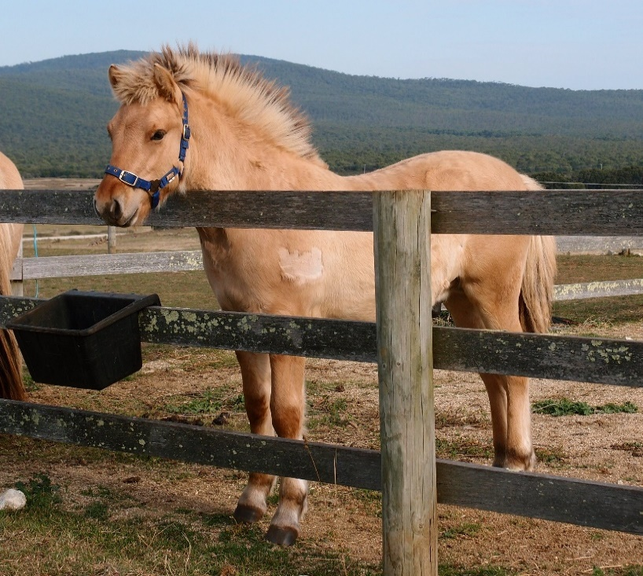

FUTURE FOALS AVAILABLE IN VICTORIA
HARKAWAY LODGE STUD (UPPER BEACONSFIELD, VICTORIA)
Expecting a foal out of Seaview Park Astrio by Tambo River Yahzuo (Pandora X MVF Erlend (USA)).
Contact Julia Grave on 0408 361 668 or fjordsandhighlands@bigpond.com
TAMBO RIVER STUD (VICTORIA)
Expecting several foals in the 2019-20 season by grey stallion Seaview Park Xanthus.
Contact Heidi Murphy at tamboriverfjords@gmail.com

FUTURE FOALS AVAILABLE IN TASMANIA
PALANA STUD (TASMANIA)
Expecting a foal out of Rachem Kerrie’s Karisma by Palana Tyson.
Contact Kerrie Prescott on 0408 088 495 or kerrieprescott@bigpond.com

